Dayton Daily News

VOICES: Can music soothe the savaged mind?
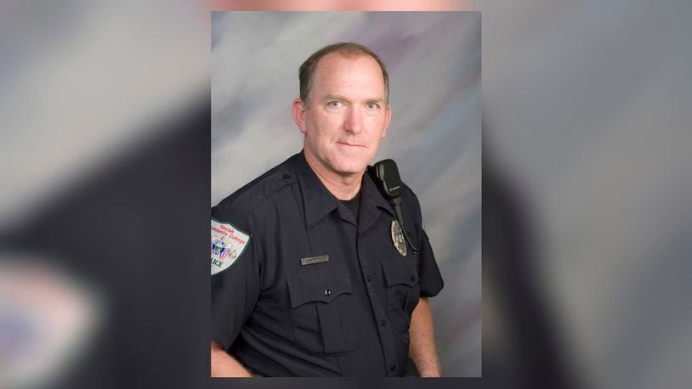
Ideas & Voices
By Tom McMurtry
January 21, 2024
The phrase “music sooths the savage beast”* describes part of my mental wellness journey. I have spent nearly my entire adult life in professions where trauma is not uncommon. I joined the Army at the age of 19 and served more than 30 years, including the invasion of Iraq. I joined the police academy at the age of 49 and was on duty the morning of the mass shooting in the Oregon District. The memories and feelings about what I have seen and what I have had to do linger and pop up at odd times. Music can stir both positive and negative emotions in me, but it can also be a treatment.
During the Iraq War I lead a small Special Ops team. Among our equipment was a loudspeaker truck. This was mostly used for crowd control. But as part of preparing for a raid, we would sometimes roll out of our compound with Drowning Pool screaming “Let the bodies hit the floor.” When it was my turn to be in the turret, I would often sing silly love songs from my teen age years out loud as I manned the machine gun. I never found out what the Iraqis thought of my versions of the Beatles greatest hits. This was wonderful ‘escape’ music. It would transport me from the brutality and stupidity of the war to a happier place and time. Singing those old familiar songs never failed to lift my spirits. But then an unexpected thing happened after I got home. Suddenly “I Want To Hold Your Hand” reminded me of the war. It would put me back in the turret. For ten years I shied away from some of my favorite music because its memory association had changed.
Over time I had learned that if I simply suppressed my negative emotions they would reemerge at inconvenient times and places. So, I used certain songs to intentionally bring up certain emotions that I had to confront. For example, my days were often busy and loud, while my nights were quiet and lonely. To deal with missing my wife I would wait until the room that I shared with 15 other soldiers was dark and settled. Then I would listen to Nora Jones sing “Come Away With Me” on low volume in my earphones and cry. After which I would get up, wash my face, hit the latrine, say my prayers, return to my cot and importantly be able to fall asleep. I had fully embraced my homesickness and could then set it aside and move on.
Through these and other experiences I have developed a method for processing event based powerful emotions. If possible before the event I try to understand and anticipate how I might feel. During the event I attempt to recognize, fully experience, and react appropriately to my emotions (positive and negative). After the event I remember, review, and learn from the event and the emotions I experienced. Then I (try) to set the emotions aside and move on. Later I can go get them if I need them to relearn lessons or teach others from my experience.
To my brothers and sisters in the military and law enforcement, what I have described works for me. Find something that works for you. These are two professions with an appallingly high rate of self-harm. Nobody thinks a broken leg is a sign of moral weakness. No one expects an infection to be cured with determination. If you need help, get help. Take your meds. Stay with us. We need every one of you.
* The Mourning Bride, 1697 by William Congreve, full quote - “Music has Charms to soothe a savage breast, to soften Rocks, or bend a knotted Oak. I’ve read, that things inanimate have mov’d, And, as with living Souls, have been inform’d.”
Tom McMurtry, U.S. Army Special Forces (retired), currently a police officer at Sinclair Community College (part-time).

